**Energy Simulation**

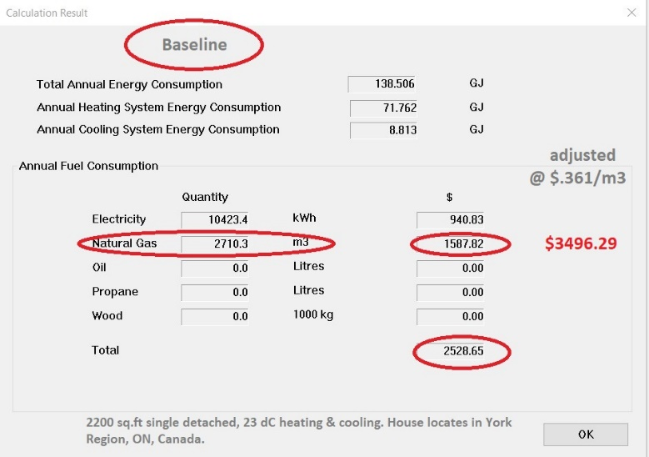 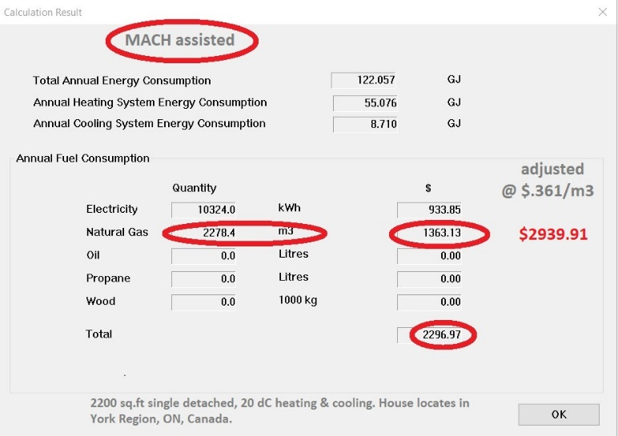

National avg. 2,385 m3, from Canadian Gas Association

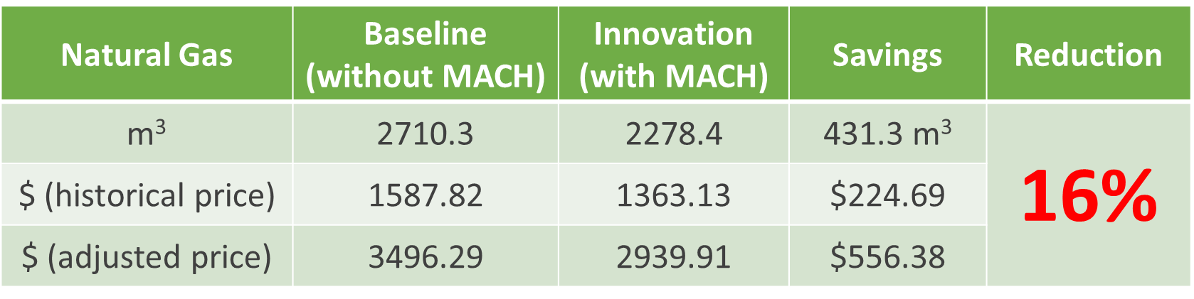

**Previously on Cargo Connect**

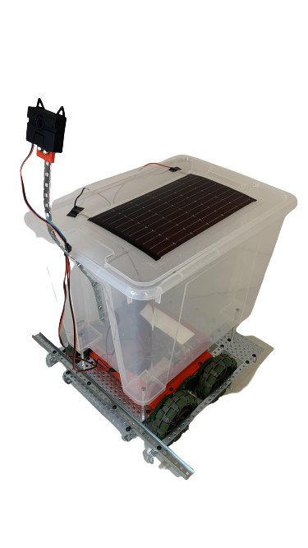 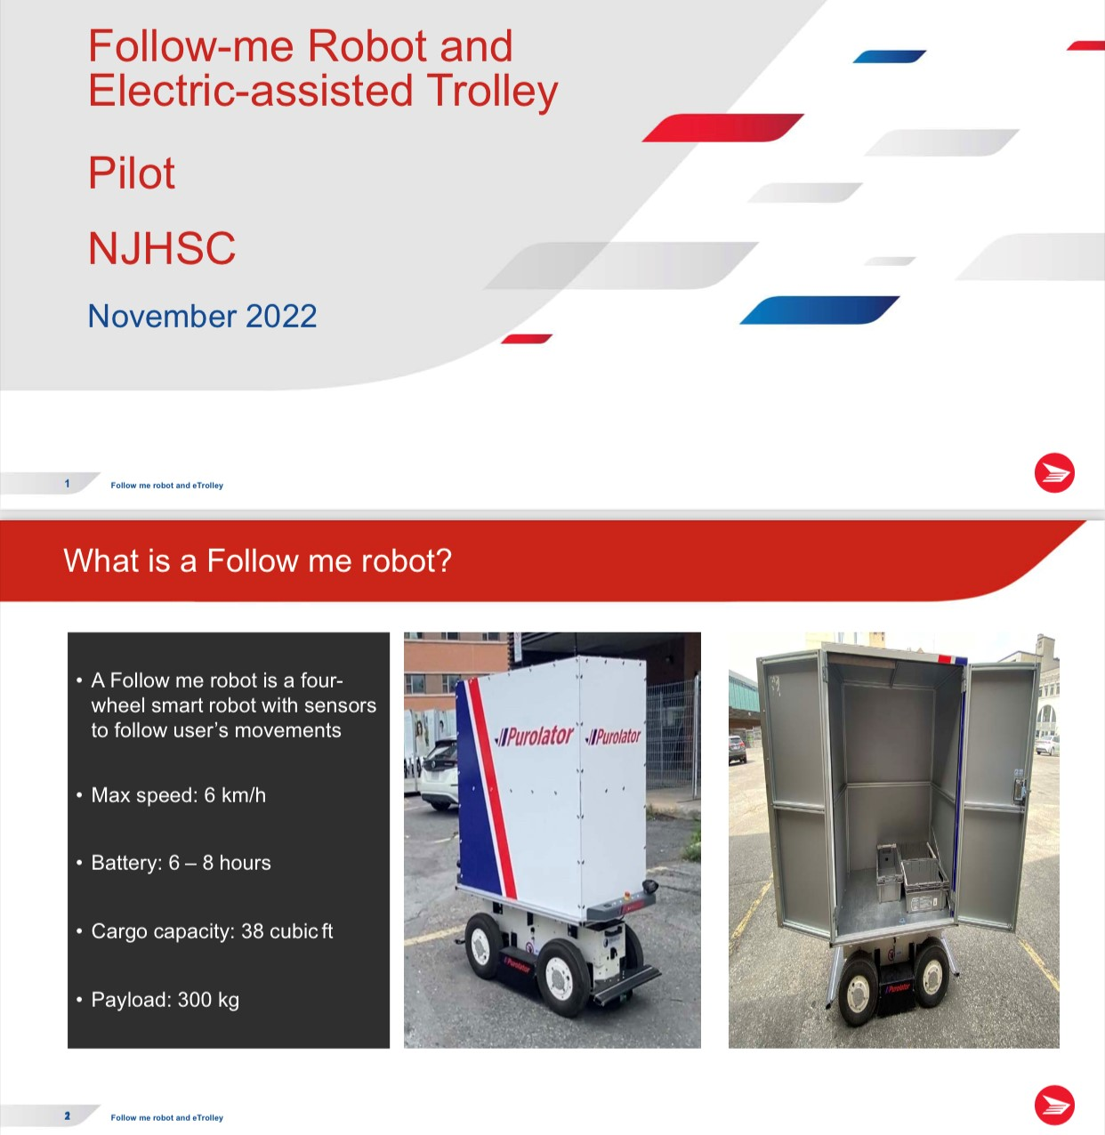

**? Bigger Payload**

**Up to 220 lb Payload**

**! Hacking in Progress**

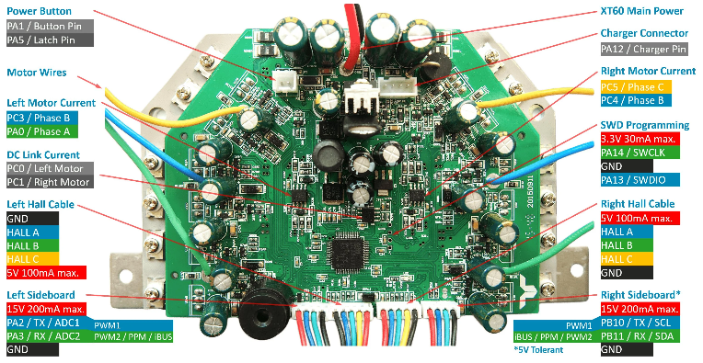 *New Problem***

**STEADY & SLOW ~~FAST~~**

**Solvers’ NEW Solution**

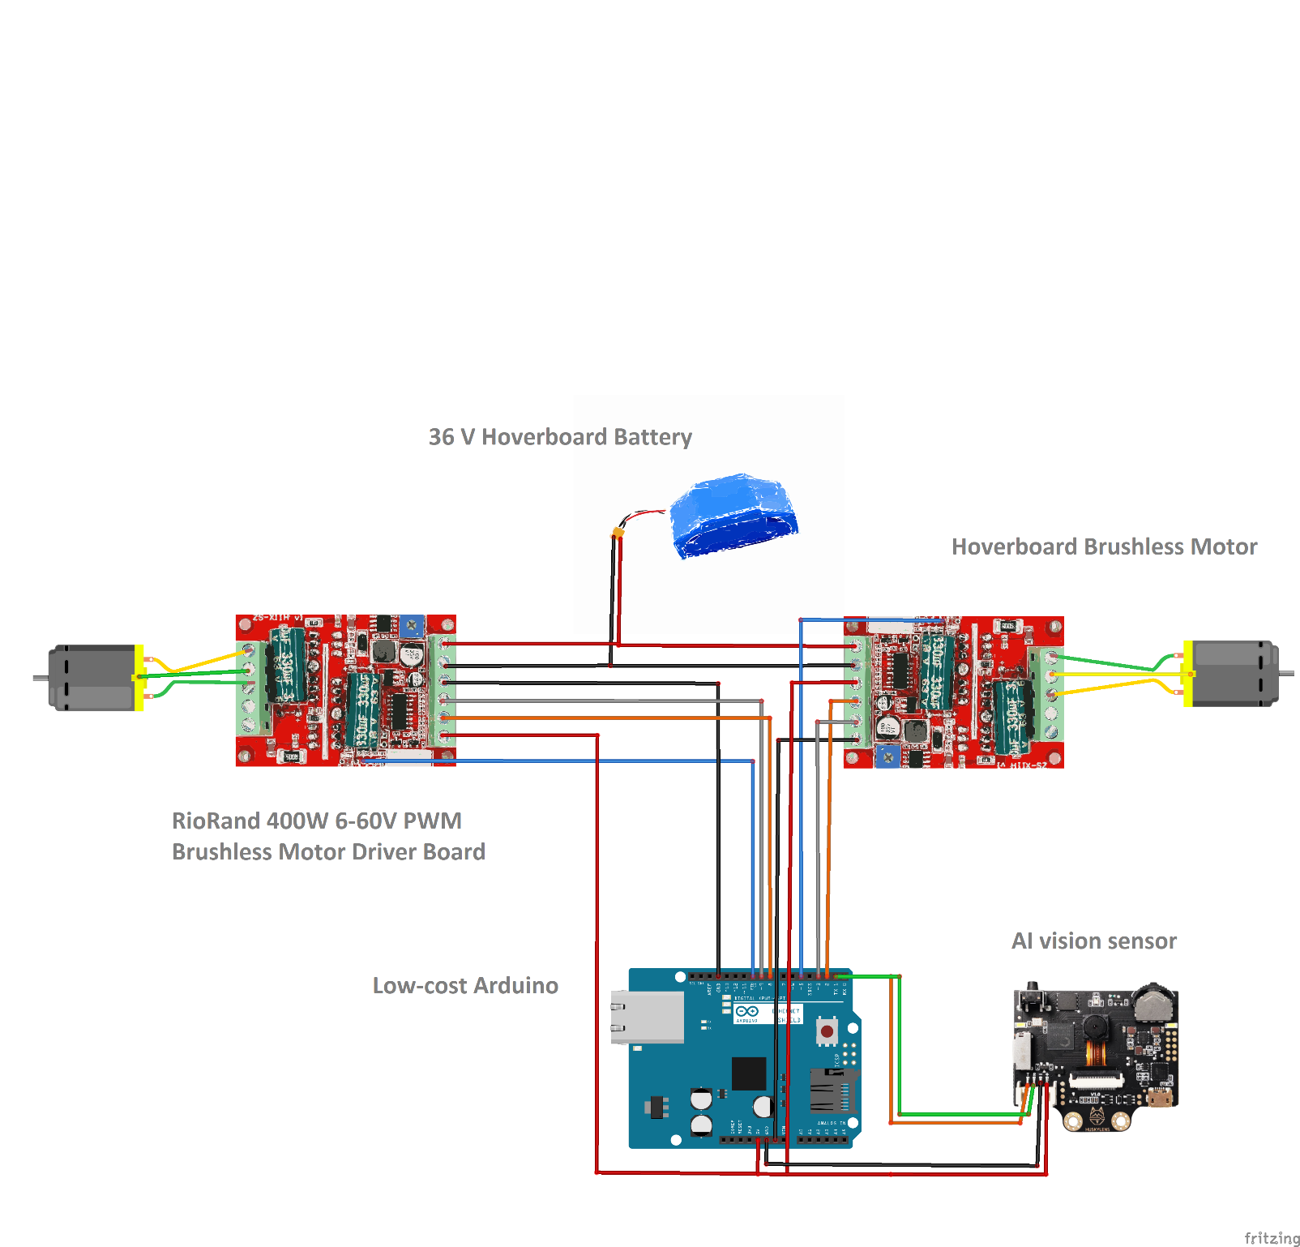

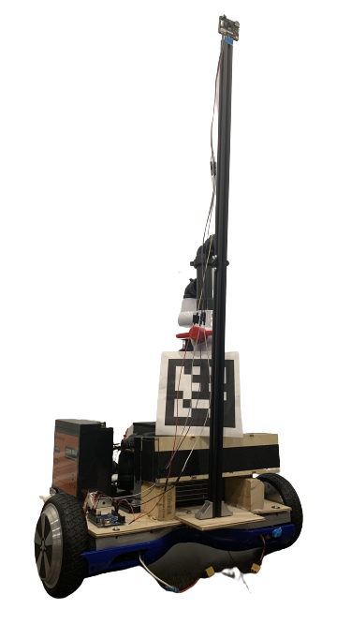

**MACH Robot**

*The Mobile Air Conditioning*

*& Heating Robot*

**Powered by**

**100 W Solar Panel**

**1%**

Total GHG Reduction!!!

COP (Coefficient of Performance)

Chassis

* Compact
* Sturdy

Attachment

* Innovative
* Forklift & dumper
* Passive & active
* Parallelogram
* Multi-tasking

Funnels

* Accuracy

**To be continued…**

**Where physics always helps…**

**Bernoulli’s principle**

**To be continued…**

**